https://leetcode.com/problems/palindrome-number/submissions/2191395153/

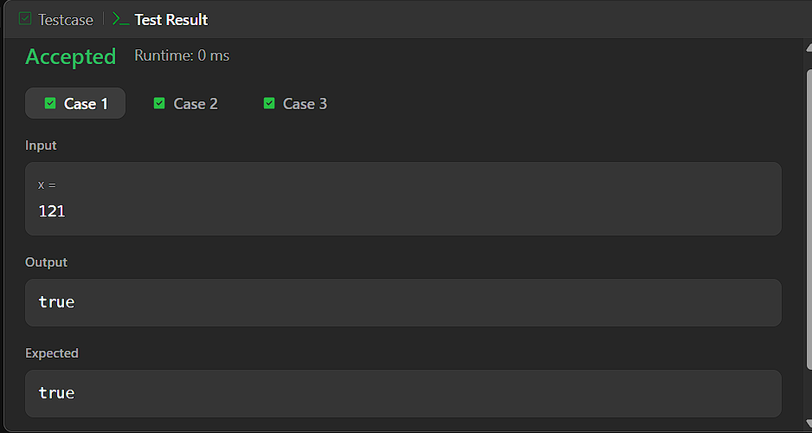


CODE:

bool isPalindrome(int x) {
if (x < 0) {
return false;
}

long long reversed = 0;
int temp = x;

while (temp > 0) {
reversed = reversed * 10 + temp % 10;
temp /= 10;
}

return reversed == x;
}

